Range-wide population monitoring with migration counts: a case study with Blackpoll Warbler

David T. Iles¹, Erica H. Dunn², Steven Van Wilgenburg³, Kevin J. Kardynal⁴, Danielle Ethier⁵, Adam C. Smith¹, Charles M. Francis¹

¹ Canadian Wildlife Service, Environment and Climate Change Canada, Ottawa, ON, Canada
² Canadian Migration Monitoring Network, Birds Canada, Port Rowan, ON, Canada
³ Canadian Wildlife Service, Environment and Climate Change Canada, Saskatoon, SK, Canada
⁴ Wildlife Research Division, Environment and Climate Change Canada, Saskatoon, SK, Canada
⁵ Birds Canada, Port Rowan, ON, Canada

*Corresponding author; Email: david.iles@canada.ca
D.T.I. ORCID: 0000-0002-7251-4938

Research paper for submission to [Journal]
18 November 2023
Acknowledgements
- We thank the numerous volunteers and employees who collected migration count data and feather samples that contributed to these analyses.
- Tara Crewe for helpful discussions related to migration modeling

Abstract

Keywords breeding origins, hierarchical model, migration monitoring, population trend, stable isotope, status assessment
Introduction
North America’s boreal forest supports billions of breeding birds from more than 300 species (Niemi et al. 1998). However, increasing industrial development in this region (Hobson et al. 2013; Mahon et al. 2014), changing forest dynamics due to rapid rates of climate change (Stralberg et al. 2015), and numerous pressures during nonbreeding periods (i.e., migration, wintering; cite) have led to concern over the status of boreal avian populations. Recent studies suggest that boreal birds appear to have experienced among the steepest population declines of any avian group, owing to large declines of several previously abundant and widespread species (Rosenberg et al. 2019; 2016). There is therefore an urgent need to develop more effective avian monitoring in the boreal forest (Cumming et al. 2010)
[Better topic sentence needed] Population trends for most North American landbirds are derived from the North American Breeding Bird Survey (BBS), which is a roadside survey with limited coverage in the mostly roadless core of the boreal zone. Consequently, the BBS samples a biased collection of boreal habitats (Van Wilgenburg et al. 2015), leading to potentially unrepresentative abundance and trend estimates for boreal species (Machtans, Kardynal, and Smith 2014). Many boreal-breeding species are also migrants to neotropical regions that are not adequately monitored by nonbreeding (i.e., “wintering”) surveys such as the Christmas Bird Count (CBC). Thus, while there are substantial data with which to estimate species distributions and habitat associations (Stralberg et al. 2015; Cumming et al. 2010), range-wide trends of most boreal species are inadequately monitored (Dunn et al. 2005).
There has long been interest in counting birds during migration to evaluate population change for species that are not amenable to monitoring during the non-migratory part of their life cycle (Francis and Hussell 1998; Dunn 2005; Farmer, Hussell, and Mizrahi 2007). The Canadian Migration Monitoring Network (CMMN) represents a collaborative initiative of bird observatories across Canada, Birds Canada, and Environment and Climate Changes Canada, with an explicit goal of monitoring avian population dynamics (Crewe et al. 2008). Several long-running migration monitoring stations are also established in the United States and have provided numerous insights into the migration ecology of North America’s boreal landbirds (e.g., McNair and Nisbet 2020; Kamm et al. 2019; Miller-Rushing et al. 2008). However, one of the main limitations of using migration counts for conservation has been lack of knowledge of the breeding origins of migrants passing count stations (i.e., station catchment). This has made it impossible to formally integrate station-level data (which have typically been analyzed on a station-by-station basis; Crewe et al. 2016; Kamm et al. 2019) into range-wide analyses that properly assimilate information from across a broad network of monitoring sites.
Advances in probabilistic origin assignments using stable isotopes, mainly hydrogen (δ²H), have led to cost-efficient methods for determining the origins of birds (hereafter “catchment”) including those arriving at migration monitoring stations (Hobson et al. 2015; Van Wilgenburg and Hobson 2011). Stable isotope analysis of migrants therefore facilitates an understanding of the geographic regions that are monitored by specific migration stations and provides a powerful opportunity to appropriately weight information across a network of migration monitoring stations and estimate large-scale patterns in population trends. This is particularly relevant to boreal-breeding birds that are not well-monitored by other methods, thereby delivering enhanced information for conservation decision-making.
Blackpoll Warbler (Setophaga striata) is an abundant Nearctic-Neotropical migrant landbird species that breeds mostly in the northern boreal forest, where breeding season surveys are extremely limited in geographic coverage. Trends derived from roadside BBS surveys suggest populations have declined by over 90% since 1970; among the steepest declines of any landbird during that period (Rosenberg et al. 2016; Sauer et al. 2017). However, the reliability of these trend estimates is uncertain owing to the absence of BBS coverage throughout the core of the species’ breeding range (Environment and Climate Change Canada 2019). Complementary monitoring methods are therefore needed for this species.
Here, we develop a Bayesian integrated population model to estimate regional and national population trends using repeated counts of migrants from a series of monitoring stations, combined with estimates of station catchments from feather stable isotope analysis. Our method synthesizes trend information at a range-wide scale by “weighting” information from migration monitoring stations based on their catchment, thereby moving beyond station-by-station analyses conducted independently. We apply this analysis to Blackpoll Warbler and compare the resulting trend estimates to those from conventional Breeding Bird Survey analysis. We also describe how this analytical framework can be readily applied to other migratory boreal species to generate estimates of range-wide population trends, and we provide fully documented R code and guidance for expanding this method to other species.
Methods
Migration count data
Our statistical model uses time series of migration counts (i.e., number of birds counted per day) collected at a network of permanent monitoring locations across Canada and the United States. The Canadian Migration Monitoring Network uses station-specific standards to collect avian counts during the spring and/or fall migration seasons. Operations are daily, weather permitting, during spring and/or fall migration. The most used count approaches include banding captures using mist nets and visual counts (hereafter ‘censuses’) that record all birds detected in a specified area during a specified time. Banding is generally done for 6 hours starting a half-hour pre-dawn at fixed net locations. The length of census counts can vary from one hour (e.g., counting birds along a ‘standard’ route) to more than six hours (e.g., continuous counts from a fixed point). Count protocols vary among stations, but within a station the count methods and daily effort are standardized and remain consistent over time (Crewe et al. 2008).
For U.S. bird observatories, net locations are usually fixed, operate similar hours to those at CMMN stations, and sample at least 5 days per week during spring and/or fall migrations. However, some stations have variable daily hours and/or number of nets. Accordingly, the number of net-hours each day can be used as a statistical offset in the analysis. Models herein were developed to accommodate daily sums of standard counts for individual stations (e.g., the number of newly banded birds plus the totals from census).
For our case study on Blackpoll Warbler, daily counts were available for XX sites during pre-breeding migration and XX sites in post-breeding migration. Analyses only included station-season combinations meeting sample size criteria (long-term abundance > 10 and detection on > 5 days per season, on average). Seasons were only included if at least 75% of days within the species’ local migration period are covered (defined as dates with counts in at least 2/3 of years in the data set). Where the full migration is covered, data were trimmed to the dates when approximately 95% of birds pass through the site, eliminating periods with numerous zeros at the start and end of each monitoring season.

Migration station catchment
Our approach estimates population trends within pre-defined geographic strata from which birds arriving at migration monitoring stations have originated. The process of defining relevant geographic strata depends on the ability to distinguish the origins of migrants from those strata, as well as prior knowledge of migration routes for a species of interest (e.g., through mark-recapture and telemetry studies). In this study, we use stable isotopes of hydrogen from feathers of birds captured at migration monitoring stations to identify the breeding origins of migrants. Stable isotopes are coarse, so strata are generally large. In cases where breeding origins can be estimated at finer scales (e.g., using radio- or GPS-telemetry), finer-scale geographic strata could be developed.
For our case study of Blackpoll Warbler, we defined two geographic strata (“Western” and “Eastern”) representing discrete regions of the North American boreal forest and Blackpoll Warbler breeding range. These strata represent regions that could be readily distinguished based on stable isotopes of hydrogen in feather samples of migrants, resulting in low uncertainty in breeding origin assignments. The boundaries of these strata are also consistent with prior knowledge of Blackpoll Warbler migration routes, based on geolocator studies that suggest migratory populations diverge into “east” and “west” directions south of James Bay.
[Description of isotope assignment methods]

Description of Statistical Model
We developed a hierarchical model to estimate temporal patterns of population change within each geographic stratum. The model simultaneously estimates annual indices of bird abundance at each migration monitoring station, and proportion of birds from each geographic stratum at each station in each year.
Equations underlying the statistical model are described in Table 1. Quantities are indexed by geographic stratum (j), year (y), monitoring station (s), and day of year (d).
The highest level of the model (equation 1) describes the temporal pattern of population change in each geographic stratum j starting from a baseline year $y_{0}$ (the year 2000 in our analysis). Our model assumes that abundance within each stratum ($X_{j,y}$) changes according to a log-linear process (see similar process models used in Smith et al. 2014; Sauer and Link 2011).
The next level of the model (equation 2) describes the expected number of migrants ($M_{j,s,y}$) arriving from each geographic stratum to each migration monitoring station during each year. $M_{j,s,y}$ is modeled as a product of annual stratum abundances $(X_{j,y})$ and time-varying migration parameters ($ρ_{j,s,y}$) that describe the contribution of stratum j to station s in year y. Year-to-year variation in $ρ_{j,s,y}$ was modeled as a time-varying log-normal random effect. The sum of $M_{j,s,y}$ across $J$ strata (equation 3) yields the expected total number of migrants arriving at the station during that year ($T_{s,y}$). The parameters $ρ_{j,s,y}$ therefore convert indices of abundance in each stratum to number of birds arriving at each station in each year.
The third level of the model (equation 4) distributes the $T_{s,y}$ migrants arriving at the monitoring station among days of the season. This component of the model is necessary because some monitoring stations are only operational for a subset of days per season; the model can therefore accommodate missing data within a season. Migration of individuals past monitoring stations is assumed to follow a symmetric seasonal pattern around a peak date. We therefore described the seasonal pattern of counts at each station using a normal probability density function $f\left(d,µ_{s},σ_{s}\right)$ that integrates to 1 across all days in a season. The parameter $µ_{s}$ is the date of the seasonal peak of migration at station $s$, while $σ_{s}$ describes the duration of the migration season at that station (i.e., approximately 95% of the station’s migration period occurs within 2$σ_{s}$ on either side of $µ_{s}$). In our application of the model, $µ_{s}$ was estimated separately for each migration monitoring station but $σ_{s}$ was estimated as a shared parameter across stations.
The final level of the model describes the observed count data (equation 6) and breeding origin estimates (equation 7). To describe migration count data, the number of birds counted on each day of the season ($d$) at each station ($s$) in each year ($y$) was modeled as an over-dispersed Poisson process with mean equal to $T_{s,y}×f\left(d, µ_{s},σ_{s}\right)$. We assumed log-normal variance for unexplained “noise” in daily counts at each station (e.g., owing to weather conditions that affect daily migration behavior), and equation 6 includes a corresponding log-normal variance correction (Sauer and Link 2011). Equation 7 also includes an offset equal to log(net hours) to account for spatio-temporal variation in monitoring effort.
Finally, we used a multinomial distribution to model breeding origins of migrants at the stations where they were collected (equation 7). In this equation, $Y_{s,y}$ is a vector containing the number of sampled birds assigned to each of the $J$ strata at a station in a year (e.g., $Y_{s,y}$ = [3, 17] represents a hypothetical sample of $x_{ s,y}$ = 20 birds arriving from 2 strata, where stable isotope analysis determined that 3 birds originated from stratum 1, and 17 birds originated from stratum 2). The latent cell probabilities describing the multinomial distribution (i.e., $\frac{M_{j,s,y}}{E_{s,y}}$) are the key that allow station-level dynamics to be linked to stratum-level dynamics.
Table 1. Multi-level statistical model to estimate population trajectories in pre-defined geographic strata by integrating daily counts of migrants at a series of monitoring stations with estimates of breeding origins for a sample of migrants at a subset of stations. Equations are indexed by geographic strata (j), year (y), monitoring station (s), and day of year (d). Equation 5 includes a log-normal bias adjustment correction as in Sauer and Link (2011).
Description | Equations
Stratum-level population process model:
Time-varying log-linear population growth process within each stratum | $${log⁡(X}_{j, y})= {log⁡(X}_{j, y-1})+r_{j}$$ | (1)
Migration process model:
Number of migrants arriving at each station from each stratum; controlled by time-varying migration parameter $ρ_{j,s,y}$ | $$M_{j,s,y}= {ρ_{j,s,y} X}_{j, y}$$ | (2)
Expected number of migrants that arrive at the station during a season, from all regions | $$T_{s,y}= \sum_{j}^{J}{M_{j,s,y}}$$ | (3)
The expected number of migrants counted on each day of the season at a station. Seasonal temporal distribution of migrants arriving at the station follows a normal curve with a mean date $µ_{s}$ and a standard deviation $σ_{s}$ | $θ_{d,s,y}= T_{s,y}×f\left(d, µ_{s},σ_{s}\right)$, where:  $$f\left({d, µ}_{s},σ_{s}\right)= \frac{1}{σ_{s}\sqrt{2π}}e^{-\frac{1}{2}(\frac{d- µ_{s}}{σ_{s}})}$$ | (4)
Observation models:
Observed number of migrants at each station on each day of year is Poisson distributed with log-normal overdispersion (controlled by $ω_{s}^{2}$), and an offset for survey effort (net hours). | $n_{d,s,y} \sim Poisson\left(λ_{d,s,y}\right)$, where:  $$\log\left(λ_{d,s,y}\right)\sim Normal\left({log⁡(θ}_{d,s,y})+\frac{1}{2}ω_{s}^{2}+{offset}_{d,s,y} ,ω_{s}^{2}\right)$$ | (5)
Multinomial distribution describes the observed breeding origins for a sample of $x$ birds collected at a station in a given year. | $$Y_{s,y} \sim Multinomial\left(x_{ s,y} , \left(\frac{M_{1,s,y}}{E_{s,y}} , \frac{M_{2,s,y}}{E_{s,y}},…,\frac{M_{J,s,y}}{E_{s,y}}\right)\right)$$ | (6)

Converting Regional Trajectories from Migration Monitoring into Regional Population Sizes
Baseline stratum abundances ($X_{j, 1}$ in equation 1) and migration parameters ($ρ_{j,s}$ in equation 2) are not separately identifiable with migration monitoring and breeding origin information alone. Without any constraints, $X_{j, 1}$ and $ρ_{j,s}$ can trade off against each other and remain equally consistent with the observed data. Thus, migration data alone cannot be used to estimate population abundance within a stratum. A straightforward solution is to fix $X_{j, 1}$ to 1 during model fitting, such that the expected relative abundance of each stratum in the baseline year $y_{0}$ is equal to 1. This enables identifiability of population trajectories in each stratum and changes the interpretation of $X_{j, y}$ to “population index in stratum $j$ relative to the baseline year”. In this formulation, the $ρ_{j,s}$ terms will often have values larger than 1 (i.e., $ρ_{j,s}$ = 1000 implies station $s$ had an expected 1000 migrants arrive from stratum $j$ in the baseline year). Under this approach, the $X_{j, y}$ estimated from the model can only be used to evaluate how much regional populations have changed relative to their own abundances in the baseline year but cannot be used to compare absolute changes in abundance among them. Estimates of $X_{j, y}$ can subsequently be rescaled outside of the model fitting procedure using independent estimates of stratum-level abundances (e.g., from species distribution models) and summed to produce estimates of national abundance.
Blackpoll Warbler Strata Definitions
We defined three geographic strata (“Western”, “Central”, and “Eastern”) representing discrete regions of the North American boreal forest and blackpoll warbler breeding range, within which we sought to estimate population trajectories using migration monitoring data (Figure 1). These strata represented regions that could be readily distinguished based on stable isotopes of hydrogen in feather samples of migrants, resulting in low uncertainty in breeding origin assignments.
- Kevin / Steve to describe breeding origin assignments (general description in main text, specific details in Appendix A).
- Reference to Figure 2, to illustrate how these data are structured. Note that these data enter the model through equation 7.
We assumed that any isotopic breeding origin assignments from up to 250 km away could be used to estimate catchment at individual migration monitoring stations. Thus, in some cases the same isotopic data were applied to multiple stations simultaneously, under the implicit assumption that nearby stations are monitoring similar portions of the species range. We also fixed the $ρ_{j,s}$ terms to 0 for several stations based on knowledge of species migration pathways (e.g., so that stations in the far northwestern portion of the continent could not capture birds from the southeastern stratum).
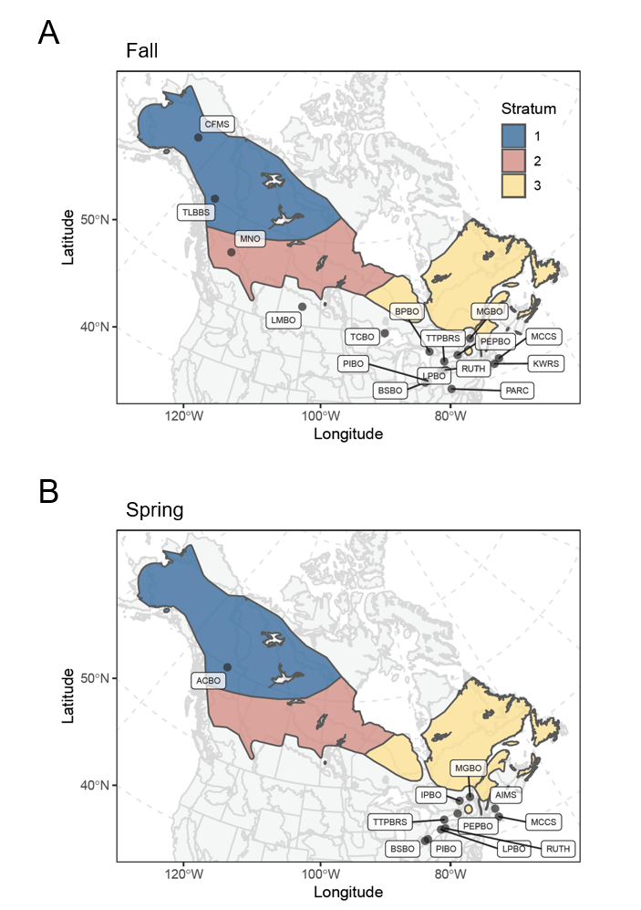
Figure 1. Stations contributing data to our analysis of Blackpoll warblers (Setophaga striata) population trends, overlaid on the three geographic strata used in our analysis.
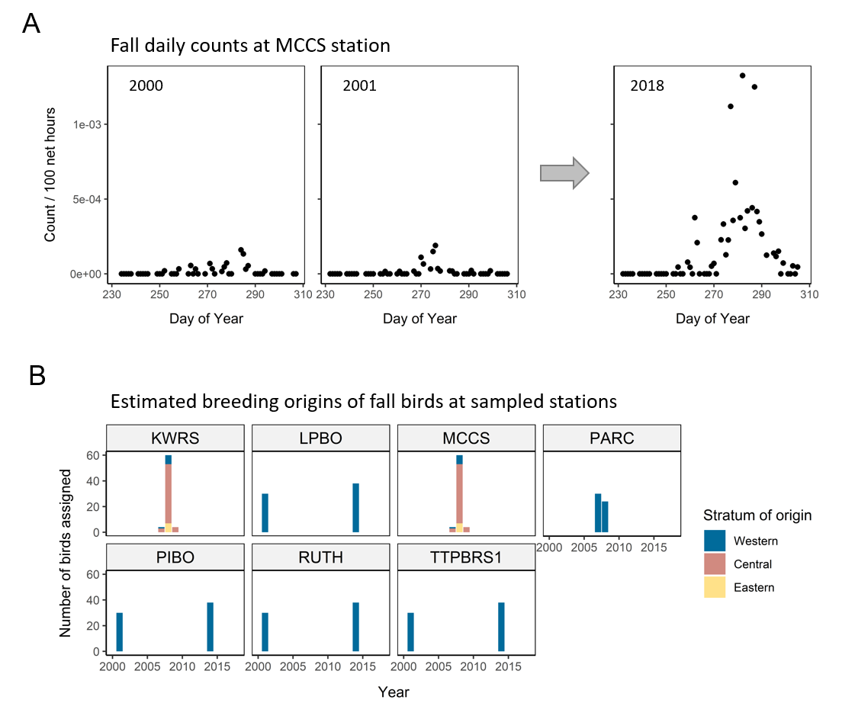
Figure 2. Illustration of data sources required to fit the statistical model. A) Fall daily counts of Blackpoll warblers (Setophaga striata) at a single station (MCCS; Manomet in Plymouth Massachusetts). Additional stations contributing migration count data to the analysis are illustrated in Figure 1. B) Estimated breeding origins of fall migrants arriving at 7 migration monitoring stations, based on stable isotope analysis of feather samples. Stable isotope analysis was also conducted at a subset of stations during spring migration (not pictured).
Calculation of Population Trends
To convert annual abundance indices ($X_{j, y}$) into population size estimates ($N_{j, y}$), we rescaled estimates of $X_{j, y}$ using spatially explicit estimates of blackpoll warbler population sizes. These estimates are derived from a species distribution model fit to avian point count data during the breeding season from over 250,000 locations across boreal Canada (BAM; Boreal Avian Modeling Project 2020). Population density surfaces are available as predicted population sizes in the year 2011 and include 32 bootstrap replicate maps that allow for spatially explicit estimates of uncertainty in density estimates. For each bootstrap replicate map, we extracted the estimated 2011 Canadian abundance of blackpoll warblers in each geographic strata and projected each of these abundances forward and backward in time using estimates of annual population change derived from our statistical model. This was repeated for each Markov Chain Monte Carlo (MCMC) posterior sample in our Bayesian analysis, yielding a full posterior distribution of regional population sizes through time for each bootstrapped density surface. National population size estimates were calculated as the sum of regional population sizes at each MCMC iteration, for each of the bootstrapped density maps.
There are numerous ways that population trends can be summarized (Sauer and Link 2011), and the most appropriate summary depends on the specific applications. The stratum-level log-scale parameters in our model ($r_{j}+\frac{1}{2}ϵ_{j}^{2}$ in equation 1) can be used to summarize the directional tendency of change in each regional population over the study (e.g., Iles et al. 2020; Che-Castaldo et al. 2017), but are strata-specific and only appropriate for the entire length of the time series. Accordingly, these parameters cannot be combined in a straightforward manner to evaluate national trends and do not accurately reflect curvilinear changes that occur through time, or necessarily at time scales relevant to conservation decision-making. The standard analysis of the North American Breeding Bird Survey instead reports trend as interval-specific geometric mean rates of change (equivalent to the realized stochastic growth rate; Koons et al. 2016), calculated from annual population indices estimated at two end points (Sauer and Link 2011; Smith et al. 2014). These measures are valid representations of population change for any temporal pattern and can be easily calculated for aggregations of multiple strata. From our model, these indices were calculated as:
$$B_{j}= {\left\{\frac{N_{j, y_{end}}}{N_{j, y_{start}}}\right\}}^{\frac{1}{y_{end}-y_{start}}},$$ | (7)
where $y_{start}$ and $y_{end}$ represent the start and end years of the interval of interest. Similarly, national trend estimates were calculated by replacing $N_{j,y}$ with $\sum_{1}^{J}{N_{j,y}}$ in equation 7.
To illustrate how our model can be used to inform species status assessments, we also calculated the percent change in population abundance from 2008 to 2018; the time period relevant to Canadian Species At Risk listing decisions. The Committee on the Status of Endangered Wildlife in Canada (COSEWIC) assigns risk categories to species based on quantitative criteria that include the magnitude of population decline over the most recent 10 years or three generations, whichever is longer. Blackpoll warblers have an estimated generation time of approximately 2 years (Ralston and Kirchman 2012); the time period relevant for COSEWIC status assessment is therefore population change over the most recent 10 years. Percent change was calculated for each stratum as $100×\frac{N_{j,2018}-N_{j,2008}}{N_{j,2008}}$, while national change was calculated as $100×\frac{\sum_{1}^{J}{N_{j,2018}}-\sum_{1}^{J}{N_{j,2008}}}{\sum_{1}^{J}{N_{j,2008}}}$.
Parameter Estimation and Model Diagnostics
We fit the statistical model in a Bayesian framework using JAGS version 4.3.0 (citation?), interfaced with the R programming language version 4.0.2 (citation?) using the jagsUI library (citation?). We specified vague priors on all model parameters; see Appendix B for details of prior specification. After a burn-in of 50,000 iterations, we stored every 50th iteration until we accumulated 1000 posterior samples from each of three MCMC chains. We assessed chain convergence by visual examination of MCMC chains and by evaluating that the Gelman–Rubin convergence statistic was close to 1 for all model parameters.
We used simulations to confirm that statistical model were able to generate unbiased estimates of regional population trends (simulation methods and results presented in Appendix C). Trends remained unbiased when including realistic regional process variance and daily migration variance, and with realistic sample sizes for stable isotope assignments (i.e., the same sample sizes, number of stations, and amount of missing data as in our empirical data).
Comparison to Breeding Bird Survey Trend Estimates
We compared our results to estimates of population trend derive using analysis of the North American Breeding Bird survey (citation?), to evaluate differences between traditional breeding season analyses and our novel migration analysis. We fit a Bayesian hierarchical model to the entire BBS time series, using analytical strata implemented by the United States Geological Survey (USGS) for continental analysis. We specified a first difference population process model (Link, Sauer, and Niven 2017; Smith and Edwards 2021), which is widely used in standard national analysis of BBS data and is the same population process model in our migration analysis (equation 1). We fit the model and extracted output using the bbsBayes package in R (Edwards and Smith 2020), specifying a 10,000 iteration burn-in period, after which we stored every 10th posterior sample until we accumulated 2000 posterior samples from each of 3 MCMC chains.
Results
Estimated blackpoll warbler population trajectories based on analysis of migration monitoring data are presented in Figures 3 and 4. Blackpoll warbler trend and population change estimates across the most recent 10 years of data (2008-2018) are presented in Table 2 to facilitate comparison with the listing criteria used by the Committee on the Status of Endangered Wildlife in Canada. We note, however, that these estimates are based on a model fit to all data from 2008? to 2018 (see Methods). Estimated population trajectories for the entire time series (2000-2018) are presented in Appendix D.
Stratum-level Population Change
Blackpoll warbler population trajectories were estimated independently from fall and spring migration data. Results for both seasons? Fall only? suggest large population declines in the eastern stratum of more than 30% over the most recent 10-year interval (Table 2). We note that few stations received migrants from the eastern stratum during fall migration, leading to large uncertainties in these trajectories prior to 2008 (Appendix D).
In contrast to the eastern stratum, both fall and spring migration trend estimates independently suggest population increases in the central stratum over the most recent 10 years. Spring trajectories were more precise than during fall migration for the central stratum (Figure 3), owing to a larger number of stations receiving migrants from that stratum during spring (Appendix D). Based on spring data, there was an 77% chance that central populations were larger in 2018 than in 2008, and only a 5% chance that the population had declined by more than 30%.
There was a 98% chance that the western population increased from 2008 to 2018 based on fall migration data. In contrast to eastern and central populations, the western stratum was not well-sampled during spring migration with only a single station received western migrants. . This lead to extremely imprecise and likely unreliable trend estimates for that stratum during spring.
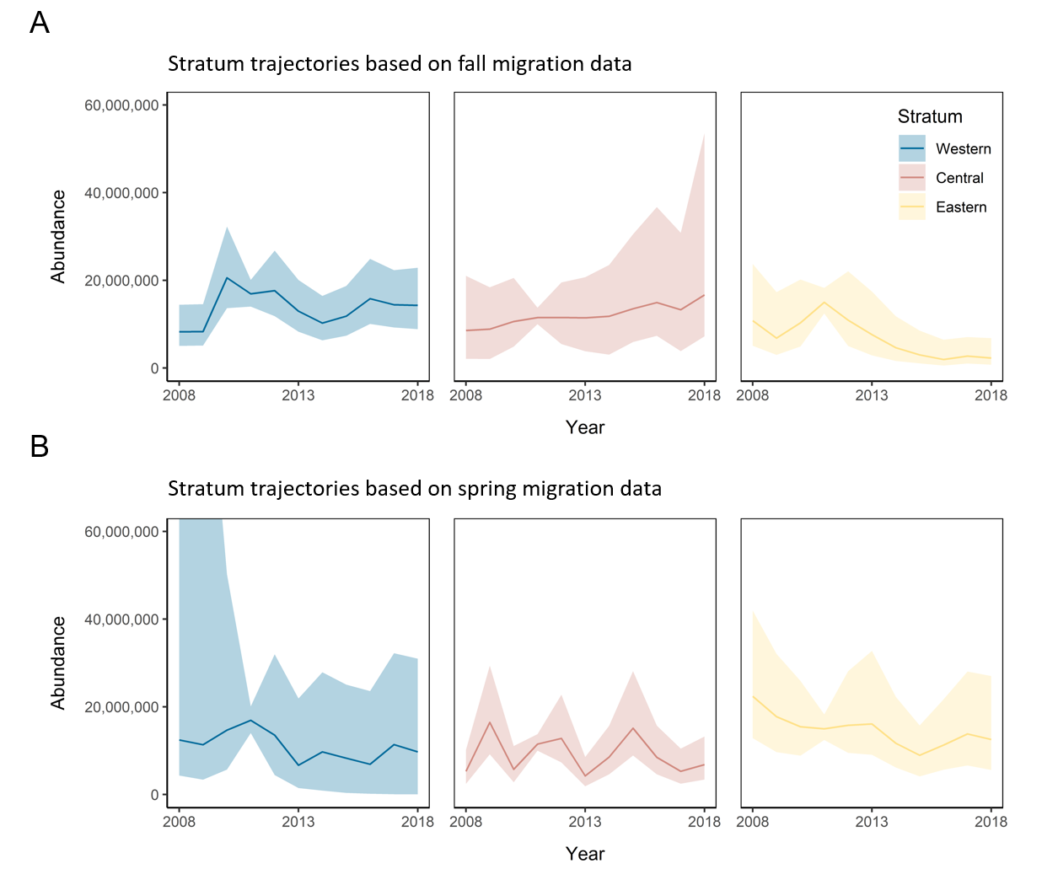
Figure 3. Estimates of stratum-level Blackpoll warblers (Setophaga striata) population trajectories based on migration monitoring during fall (A) and spring (B) periods. Regional population estimates in 2011 with associated uncertainty are derived from the Boreal Avian Modeling Project’s Canada-wide landbird density estimates version 4.0 (2020) while population estimates in other years are derived based on annual change estimates from the fitted statistical model (Table 1). Solid lines represent mean of the Bayesian posterior distribution; ribbons represent 95% credible intervals.
National Population Change
There was low support for national population declines over the most recent 10 years based on fall migration trajectories. In contrast, there was a 79% chance the national population has increased (Table 2). Simultaneously, there was only a 2% chance that a 30% national population decline had occurred. Since the estimated fall population trajectory in the eastern stratum is strongly influenced by data at a single station (MGBO; see Appendix E), national trend estimates based solely on fall migration should be interpreted cautiously. Similarly, spring trends in the western stratum are only informed by data from a single station. We therefore did not make national-level inference based on spring migration data.
National trend estimates were most precise when calculated based on a composite national trajectory, constructed using trajectories for each stratum from the season in which the largest number of stations capture migrants from that stratum (i.e., fall migration for the western stratum, and spring migration for the central and eastern strata). Based on this national composite trajectory, blackpoll warbler populations are unlikely to have experienced large population changes across the most recent 10 years of monitoring; the median estimate of 10-year change was -5.6% (Table 1). Accordingly, there was only a 6% chance that the national population declined by 30% over 10 years, which is the COSEWIC threshold for Threatened status.
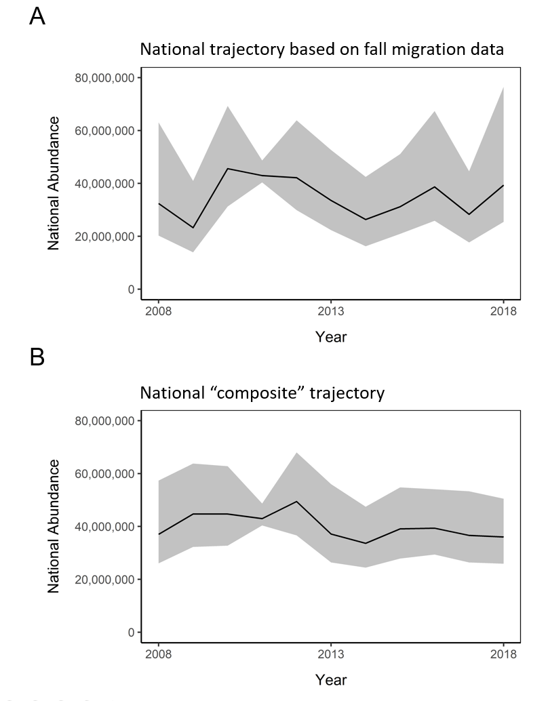
Figure 4. Estimates of national-level Blackpoll warblers (Setophaga striata) population trajectories (from 2008 to 2018) derived by summing stratum-level abundance estimates for each Bayesian posterior sample in our migration model. Solid lines represent mean of the Bayesian posterior distribution; ribbons represent 95% credible intervals. Panel A) trajectory based on summing stratum estimates using fall trajectories only. Panel B) trajectory based on summing fall trajectory for Western stratum and spring trajectory for Central and Eastern strata. We do not present national trajectory based on only spring trajectories because the western trajectory during spring is likely unreliable (see main text).

Table 2. Estimates of trend (using equation 7), abundance change, probability of population increase, and probability of population decline in Blackpoll warblers (Setophaga striata) from 2008 to 2018 in each stratum and nationally; 95% credible intervals in parentheses for trend and % change. Composite trajectory was calculated by summing fall trajectory for Western stratum and spring trajectory for Central and Eastern strata.
Region | 10-year trend | Percent change | P(increase) | P(30% decline)
Fall migration:
Western | 0.056 (0.0003, 0.110) | +72.5 (+0.3, +182.9) | 0.976 | 0.000
Central | 0.087 (-0.023, 0.235) | +129.7 (-20.9, +724.7) | 0.929 | 0.014
Eastern | -0.144 (-0.231, -0.047) | -78.9 (-92.8, -37.9) | 0.003 | 0.984
National | 0.021 (-0.031, 0.091) | +23.7 (-26.4, +138.7) | 0.785 | 0.016
Spring migration:
Western | -0.018 (-0.602 to 0.098) | -16.6 (-100, +154.6) | 0.361 | 0.379
Central | 0.026 (-0.047 to 0.105) | +29.8 (-38.0, +170.5) | 0.768 | 0.048
Eastern | -0.056 (-0.124 to -0.008) | -44.1 (-73.4, +8.3) | 0.042 | 0.748
Composite trajectory:
National | -0.005 (-0.044 to 0.031) | -5.6 (-36.7, +35.4) | 0.374 | 0.063

Comparison to Breeding Bird Survey Trend Estimates
Spatial patterns in trend estimates based on analysis of the North American Breeding Survey were only partially consistent with those from migration monitoring (Figure 5A). Similar to migration monitoring, BBS analysis suggested steep declines in eastern strata. However, BBS analysis indicated population declines in several large western strata, which is partially inconsistent with fall migration monitoring results, which suggest increases in the western population. There were insufficient BBS data to include in analysis of several central strata, resulting in an absence of trend estimates for large portions of northern-central Canada.
The national trend estimate based on BBS was more negative than the composite national estimate derived from migration monitoring. The trend based on BBS was -0.024 (CI: -0.059. 0.017), yielding a 10-year change estimate of -21.9% (CI: -45.3, +18.4). There was a corresponding 26% chance that the population had declined by more than 30% on BBS analysis.
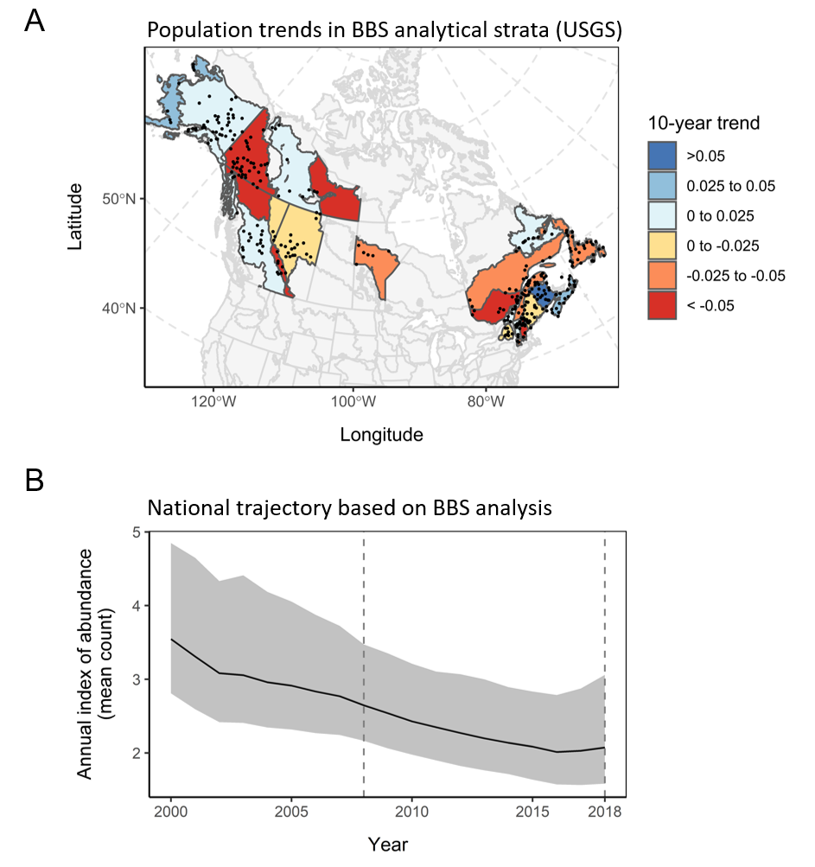
Figure 5. Blackpoll warblers (Setophaga striata) regional population trends (A) and Canadian national population trajectory (B) estimates derived from analysis of the North American Breeding Bird Survey. Panel A) points indicate start locations of BBS routes contributing data to the analysis. Analytical strata are defined as in the standard USGS analysis. Panel B) estimated population trajectory across the same period as the migration monitoring analysis; dashed vertical lines indicate the most recent 10-year period for comparison to Figure 4.
Discussion
Using a novel statistical model, we generated national population trend estimates from migration monitoring data. Applying this model to a boreal breeding songbird revealed more optimistic 10-year national trend estimates than those derived from Breeding Bird Surveys that are largely collected at the periphery of the species range. Estimates derived from the BBS suggest that blackpoll warblers comprise 10% (307 million) of the estimated 3 billion breeding birds across all species that no longer exist in North America relative to 1970 (see Data S1 in Rosenberg et al. 2019). Accordingly, the blackpoll warbler is considered a common bird in steep decline and a priority for ongoing monitoring and conservation (Rosenberg et al. 2016). Our analysis suggests that steep population declines are unlikely to have occurred nationally across the three most recent generations for this species, and that there is a low probability blackpoll warbler currently meets COSEWIC criteria for Threatened status designation.
Our findings are consistent with ecological theory that predicts population trends are less positive at species range margins, where habitat quality is lower and environmental conditions are further from a species’ optimum (MacArthur 1984; Hargreaves, Samis, and Eckert 2014). Theory also predicts that species will be more sensitive to environmental change at range margins, though empirical evidence for this prediction is mixed (Amburgey et al. 2018; Kleinhesselink and Adler 2018; Iles et al. 2020). The North American Breeding Bird Survey, as a roadside survey, contains large spatial gaps in the core of the roadless boreal forest and therefore primarily samples the periphery of boreal species’ ranges. This spatial bias leads to an unrepresentative sample of boreal habitats and anthropogenic disturbance, which is more severe near inhabited roadside areas (Van Wilgenburg et al. 2015; Dunn et al. 2005). If BBS surveys are restricted to the periphery of a species range, and in disproportionately disturbed habitats, trends derived from the BBS will be more negative than methods that survey the core of the range. Indeed, a long-term study of 50 species at an intact boreal study site found that population trends were on average more positive than regional and national BBS trends (Machtans, Kardynal, and Smith 2014). Our national migration trends were also more positive than BBS trends, which is consistent with this hypothesis; the migration monitoring network likely captures individuals from across the entire boreal range (Hobson et al. 2015; Dunn 2005) rather than disproportionately monitoring populations at range margins.
Climate-driven range shifts could also lead to the discrepancy we identified between trends based on breeding and migration surveys. In the case of the Breeding Bird Survey, a northward shift in population range for boreal-breeding species could masquerade as spurious population declines, given that most BBS survey locations are largely restricted to the southern periphery of the Canadian boreal forest. Thus, individuals shifting northward out of the BBS sampling frame would appear as a population decline, even if abundance were stable nationally. Recent evidence suggests that a 600 km northward shift in blackpoll warbler breeding range has likely occurred over the last 45 years (Gómez et al. 2021), coinciding with the period during which trends derived from BBS have been highly negative. In this case, migration monitoring may be more robust to climate-driven range shifts because populations that have shifted their breeding locations will nevertheless continue to be surveyed during their migration.
Migration analysis yielded short-term national trend estimates that had similar precision to those from the BBS, but a lack of historical migration counts and stable isotope data precluded usefully precise long-term estimates of population performance from migration monitoring (i.e., prior to 2008). We therefore cannot compare migration-based trend analysis to those from breeding surveys during the period in which the steepest population declines appear to have occurred for this species. Nevertheless, application of our method to other boreal breeding species would provide a strong test of the hypothesis that BBS-derived trends are overly pessimistic for species experiencing northward range shifts and/or species with large populations in the roadless core of the boreal forest. Simultaneously, our analytical approach could provide valuable insights for other groups of birds that are more reliably covered on migration or at stopover sites, such as shorebirds and raptors (Farmer, Hussell, and Mizrahi 2007), for which BBS-derived trend estimates are highly uncertain.
Independent estimates of abundance within each analytical stratum are required to properly “weight” regional trajectories and produce a national trajectory (see Converting Regional Trajectories from Migration Monitoring into Regional Population Sizes in Methods section). For North American landbirds, considerable progress has been made towards understanding the relative strengths and limitations of different datasets used for this purpose (Sólymos et al. 2020; Thogmartin 2010; Confer et al. 2008). Our analysis relied on population abundance estimates produced from boosted regression trees trained on hundreds of thousands of avian point counts collected across the Canadian boreal forest (Stralberg et al. 2015; Boreal Avian Modeling Project 2020), with explicit corrections for variation in survey methodology among observations (Sólymos et al. 2013). New efforts to deploy a rigorously designed national sampling protocol across the entire Canadian boreal forest also hold immense promise for producing improved estimates of landbird densities (Van Wilgenburg et al. 2020), that can be used to both test predictions from our model and generate improved model outputs.
Possibly insert a paragraph about the east/west gradient that appears to occur in both the migration and BBS data?
- Causes of this gradient? Things to discuss?
- Somewhat worried that the discussion is too “blackpollish”, and not general enough. Adding this paragraph would make the paper even more species-specific. Thoughts/advice?
The current formulation of our model assumes that migration pressure is constant through time (i.e., $ρ_{j,s}$ has no temporal component; Table 1) and that directional changes in abundance of migrants are due to changes in regional population sizes, rather than directional shifts in migration routes. Repeated sampling of migrants for stable isotopes at multiple stations could be used to evaluate whether station catchment is changing over time and would allow for temporal components to be added to the $ρ_{j,s}$ terms. Importantly, our model makes explicit predictions about the proportion of migrants from each region in a station’s annual catchment (equations 2, 3, and 7). Iteratively confronting predictions with new data is the strongest test of scientific theory and the fastest way to improve ecological understanding (Dietze et al. 2018), and we therefore consider the collection of new stable isotope data across the migration network a priority for further model testing and refinement.
Moving forward, our model could potentially be extended to incorporate non-standardized migration count data from citizen science networks such as eBird (Sullivan et al. 2014), conceptually equivalent to adding thousands of migration monitoring “stations” across the continent. This would have numerous advantages including more comprehensive coverage of migratory populations and reducing the influence of any single migration monitoring station on regional trend estimates. However, reliance on citizen science information requires careful screening of data and appropriate accounting of changes in observer effort over time (e.g., through modeling). For migration monitoring, this also requires limiting data to locations outside breeding and/or wintering areas to avoid confounding changes in migrant numbers with signals of change in local numbers of seasonal residents. Simultaneously, the continual improvement of wildlife tracking technologies will undoubtedly yield finer resolution estimates of migration behaviour, and thus, station catchment. Future integrated analysis of these data would allow trends to be estimated in a larger number of higher resolution strata, yielding enhanced information at conservation-relevant scales.
Interpretation of station-level trends is also complicated by the “loop migration” behaviour of blackpoll warblers, wherein populations follow very different migration routes during spring and fall (Holberton et al. 2015; Covino et al. 2020; DeLuca et al. 2019). A single station may therefore be monitoring birds originating from different origins of the breeding range during each migration season. Furthermore, most of the continental population appears to congregate along the northeast coast of the United States during fall migration, prior to undertaking a transoceanic flight to nonbreeding areas in South America (Holberton et al. 2015; DeLuca et al. 2015; Nisbet et al. 1995). Thus, stations in this region are likely to capture a mixture of birds from across the breeding range.

Authors’ Contributions
All authors conceived of research ideas. EHD and DE compiled and cleaned migration count data. SVW and KJK conducted statistical analyses of feather isotopes to determine breeding origins. DTI developed statistical model, led analysis, and wrote the manuscript. All authors contributed critically to manuscript drafts and gave final approval for publication.

Data Accessibility
Canadian migration count data are publicly available at the NatureCounts portal (https://www.bsc-eoc.org/birdmon/cmmn/datasets.jsp), managed by Birds Canada. US migration counts are available upon request from individual migration monitoring stations. All isotope data, code, and Bayesian posterior samples associated with these analyses will be archived in Dryad Digital Repository upon acceptance of this manuscript.

Conflict of Interest
The authors declare they have no conflict of interest.

Compliance with Ethical Standards
The authors declare that they have complied with ethical standards.
References
Amburgey, Staci M., David A. W. Miller, Evan H. Campbell Grant, Tracy A. G. Rittenhouse, Michael F. Benard, Jonathan L. Richardson, Mark C. Urban, et al. 2018. “Range Position and Climate Sensitivity: The Structure of among-Population Demographic Responses to Climatic Variation.” Global Change Biology 24: 439–54. https://doi.org/10.1111/gcb.13817.
Birds Canada. 2020. “NatureCounts - Canadian Migration Monitoring Network.” 2020. https://www.birdscanada.org/birdmon/cmmn/popindices.jsp?what=trendmaps.
Boreal Avian Modeling Project. 2020. “New Canada-Wide Land Bird Density Estimates (Version 4.0).” The Boreal Avian Modelling Project. 2020. https://borealbirds.ualberta.ca/maps-data/data-products-2/new-canada-wide-land-bird-density-estimates-version-4/.
Che-Castaldo, Christian, Stephanie Jenouvrier, Casey Youngflesh, Kevin T. Shoemaker, Grant Humphries, Philip McDowall, Laura Landrum, Marika M. Holland, Yun Li, and Rubao Ji. 2017. “Pan-Antarctic Analysis Aggregating Spatial Estimates of Adélie Penguin Abundance Reveals Robust Dynamics despite Stochastic Noise.” Nature Communications 8: 832. https://doi.org/10.1038/s41467-017-00890-0.
Confer, John L., Rebecca E. Serrell, Mark Hager, and Eleanor Lahr. 2008. “Field Tests of the Rosenberg-Blancher Method for Converting Point Counts to Abundance Estimates.” The Auk 125 (4): 932–38.
Covino, Kristen, Sara Morris, Mark Shieldcastle, and Philip Taylor. 2020. “Spring Migration of Blackpoll Warblers across North America.” Avian Conservation and Ecology 15 (1).
Crewe, Tara L., Jon D. McCracken, Philip D. Taylor, Denis Lepage, and Audrey E. Heagy. 2008. “The Canadian Migration Monitoring Network-Réseau Canadien de Surveillance Des Migrations: Ten-Year Report on Monitoring Landbird Population Change.” CMMN-RCSM Scientific Technical Report 1.
Cumming, Steven G., E. Bayne, F. K. A. Schmiegelow, Trish Fontaine, S. J. Song, and K. Lefevre. 2010. “Toward Conservation of Canada’s Boreal Forest Avifauna: Design and Application of Ecological Models at Continental Extents.”
DeLuca, William V., Bradley K. Woodworth, Stuart A. Mackenzie, Amy EM Newman, Hilary A. Cooke, Laura M. Phillips, Nikole E. Freeman, Alex O. Sutton, Lila Tauzer, and Carol McIntyre. 2019. “A Boreal Songbird’s 20,000 Km Migration across North America and the Atlantic Ocean.” Bulletin of the Ecological Society of America 100 (3): 1–5.
DeLuca, William V., Bradley K. Woodworth, Christopher C. Rimmer, Peter P. Marra, Philip D. Taylor, Kent P. McFarland, Stuart A. Mackenzie, and D. Ryan Norris. 2015. “Transoceanic Migration by a 12 g Songbird.” Biology Letters 11 (4): 20141045.
Dietze, Michael C., Andrew Fox, Lindsay M. Beck-Johnson, Julio L. Betancourt, Mevin B. Hooten, Catherine S. Jarnevich, Timothy H. Keitt, Melissa A. Kenney, Christine M. Laney, and Laurel G. Larsen. 2018. “Iterative Near-Term Ecological Forecasting: Needs, Opportunities, and Challenges.” Proceedings of the National Academy of Sciences 115: 1424–32. https://doi.org/10.1073/pnas.1710231115.
Dunn, Erica H. 2005. “Counting Migrants to Monitor Bird Populations: State of the Art.” USDA Forest Service General Technical Report PSW-GTR-191, 712–17.
Dunn, Erica H., B. L. Altman, J. Bart, C. J. Beardmore, H. Berlanga, P. J. Blancher, G. S. Butcher, D. W. Demarest, R. Dettmers, and W. C. Hunter. 2005. High Priority Needs for Range-Wide Monitoring of North American Landbirds. Partners in Flight Technical Series 2. Partners in Flight.
Edwards, Brandon PM, and Adam C. Smith. 2020. “BbsBayes: An R Package for Hierarchical Bayesian Analysis of North American Breeding Bird Survey Data.” BioRxiv.
Environment and Climate Change Canada. 2019. “Blackpoll Warbler.” Status of Birds in Canada. 2019. https://wildlife-species.canada.ca/bird-status/oiseau-bird-eng.aspx?sY=2019&sL=e&sM=a&sB=BLPW.
Farmer, Christopher J., David JT Hussell, and David Mizrahi. 2007. “Detecting Population Trends in Migratory Birds of Prey.” The Auk 124 (3): 1047–62.
Francis, C. M., and D. J. T. Hussell. 1998. “Changes in Numbers of Land Birds Counted in Migration at Long Point Bird Observatory, 1961-1997.” Bird Populations 4: 37–66.
Gómez, Camila, Keith A. Hobson, Nicholas J. Bayly, Kenneth V. Rosenberg, Andrea Morales-Rozo, Paula Cardozo, and Carlos Daniel Cadena. 2021. “Migratory Connectivity Then and Now: A Northward Shift in Breeding Origins of a Long-Distance Migratory Bird Wintering in the Tropics.” Proceedings of the Royal Society B 288 (1948): 20210188.
Hargreaves, Anna L., Karen E. Samis, and Christopher G. Eckert. 2014. “Are Species’ Range Limits Simply Niche Limits Writ Large? A Review of Transplant Experiments beyond the Range.” The American Naturalist 183 (2): 157–73.
Hobson, Keith, Steven L. Van Wilgenburg, Erica Dunn, David Hussell, Philip Taylor, and Douglas Collister. 2015. “Predicting Origins of Passerines Migrating through Canadian Migration Monitoring Stations Using Stable-Hydrogen Isotope Analyses of Feathers: A New Tool for Bird Conservation.” Avian Conservation and Ecology 10 (1).
Hobson, Keith, Amy Wilson, Steven L. Van Wilgenburg, and Erin Bayne. 2013. “An Estimate of Nest Loss in Canada Due to Industrial Forestry Operations.” Avian Conservation and Ecology 8 (2).
Holberton, Rebecca L., Steven L. Van Wilgenburg, Adrienne J. Leppold, and Keith A. Hobson. 2015. “Isotopic (Δ2Hf) Evidence of ‘Loop Migration’ and Use of the Gulf of Maine Flyway by Both Western and Eastern Breeding Populations of Blackpoll Warblers.” Journal of Field Ornithology 86 (3): 213–28.
Hooten, Mevin B., and N. Thompson Hobbs. 2015. “A Guide to Bayesian Model Selection for Ecologists.” Ecological Monographs 85 (1): 3–28.
Iles, David T., Heather Lynch, Rubao Ji, Christophe Barbraud, Karine Delord, and Stephanie Jenouvrier. 2020. “Sea Ice Predicts Long‐term Trends in Adélie Penguin Population Growth, but Not Annual Fluctuations: Results from a Range‐wide Multiscale Analysis.” Global Change Biology 26 (7): 3788–98.
Kamm, Matthew D., Trevor L. Lloyd-Evans, Maina Handmaker, and J. Michael Reed. 2019. “A Half-Century of Changes in Migratory Landbird Numbers along Coastal Massachusetts.” PloS One 14 (9): e0222232.
Kleinhesselink, Andrew R, and Peter B Adler. 2018. “The Response of Big Sagebrush (Artemisia Tridentata) to Interannual Climate Variation Changes across Its Range.” Ecology 99: 1139–49. https://doi.org/10.1002/ecy.2191.
Koons, David N., David T. Iles, Michael Schaub, and Hal Caswell. 2016. “A Life‐history Perspective on the Demographic Drivers of Structured Population Dynamics in Changing Environments.” Ecology Letters 19: 1023–31. https://doi.org/10.1111/ele.12628.
Link, William A., John R. Sauer, and Daniel K. Niven. 2017. “Model Selection for the North American Breeding Bird Survey: A Comparison of Methods.” The Condor: Ornithological Applications 119 (3): 546–56.
MacArthur, Robert H. 1984. Geographical Ecology: Patterns in the Distribution of Species. Princeton University Press.
Machtans, Craig, Kevin Kardynal, and Paul Smith. 2014. “How Well Do Regional or National Breeding Bird Survey Data Predict Songbird Population Trends at an Intact Boreal Site?” Avian Conservation and Ecology 9 (1).
Mahon, C. Lisa, Erin M. Bayne, Péter Sólymos, Steven M. Matsuoka, Matthew Carlson, Elston Dzus, Fiona KA Schmiegelow, and Samantha J. Song. 2014. “Does Expected Future Landscape Condition Support Proposed Population Objectives for Boreal Birds?” Forest Ecology and Management 312: 28–39.
McNair, Douglas B., and Ian CT Nisbet. 2020. “Status and Abundance of Blackpoll Warblers in Autumn on the Coast of the Southeastern United States: An Update.” Southeastern Naturalist 19 (2): 241–55.
Miller-Rushing, A.J., T.L. Lloyd-Evans, Richard B. Primack, and Paul Satzinger. 2008. “Bird Migration Times, Climate Change, and Changing Population Sizes.” Global Change Biology 14 (9): 1959–72.
Niemi, Gerald, JoAnn Hanowski, Pekka Helle, Robert Howe, Mikko Mönkkönen, Lisa Venier, and Daniel Welsh. 1998. “Ecological Sustainability of Birds in Boreal Forests.” Conservation Ecology 2 (2).
Nisbet, Ian CT, Douglas B. McNair, William Post, and Timothy C. Williams. 1995. “Transoceanic Migration of the Blackpoll Warbler: Summary of Scientific Evidence and Response to Criticisms by Murray (Migración Transoceánica de Dendroica Striata: Resumen de Investigaciones y Respuesta a La Crítica de Murray).” Journal of Field Ornithology, 612–22.
Ralston, Joel, and Jeremy J. Kirchman. 2012. “Continent-Scale Genetic Structure in a Boreal Forest Migrant, the Blackpoll Warbler (Setophaga Striata).” The Auk 129 (3): 467–78.
Rosenberg, K. V., J. A. Kennedy, R. Dettmers, R. P. Ford, D. Reynolds, J. D. Alexander, C. J. Beardmore, P. J. Blancher, R. E. Bogart, and G. S. Butcher. 2016. “Partners in Flight Landbird Conservation Plan: 2016 Revision for Canada and Continental United States.” Partners in Flight Science Committee 35.
Rosenberg, K.V., Adriaan M. Dokter, Peter J. Blancher, John R. Sauer, Adam C. Smith, Paul A. Smith, Jessica C. Stanton, Arvind Panjabi, Laura Helft, and Michael Parr. 2019. “Decline of the North American Avifauna.” Science 366 (6461): 120–24.
Sauer, John, Daniel Niven, James Hines, David Ziolkowski Jr, Keith L. Pardieck, J. E. Fallon, and William Link. 2017. “The North American Breeding Bird Survey, Results and Analysis 1966-2015.”
Sauer, John R., and William A. Link. 2011. “Analysis of the North American Breeding Bird Survey Using Hierarchical Models.” The Auk 128 (1): 87–98.
Smith, Adam C., and Brandon PM Edwards. 2021. “North American Breeding Bird Survey Status and Trend Estimates to Inform a Wide Range of Conservation Needs, Using a Flexible Bayesian Hierarchical Generalized Additive Model.” The Condor 123 (1): duaa065.
Smith, Adam C., Marie-Anne R. Hudson, Constance Downes, and Charles M. Francis. 2014. “Estimating Breeding Bird Survey Trends and Annual Indices for Canada: How Do the New Hierarchical Bayesian Estimates Differ from Previous Estimates?” The Canadian Field-Naturalist 128 (2): 119–34.
Sólymos, Péter, Steven M. Matsuoka, Erin M. Bayne, Subhash R. Lele, Patricia Fontaine, Steve G. Cumming, Diana Stralberg, Fiona KA Schmiegelow, and Samantha J. Song. 2013. “Calibrating Indices of Avian Density from Non‐standardized Survey Data: Making the Most of a Messy Situation.” Methods in Ecology and Evolution 4 (11): 1047–58.
Sólymos, Péter, Judith D Toms, Steven M Matsuoka, Steven G Cumming, Nicole K S Barker, Wayne E Thogmartin, Diana Stralberg, et al. 2020. “Lessons Learned from Comparing Spatially Explicit Models and the Partners in Flight Approach to Estimate Population Sizes of Boreal Birds in Alberta, Canada.” The Condor 122 (2). https://doi.org/10.1093/condor/duaa007.
Stralberg, D., S. M. Matsuoka, A. Hamann, E. M. Bayne, P. Sólymos, F. K. A. Schmiegelow, X. Wang, S. G. Cumming, and S. J. Song. 2015. “Projecting Boreal Bird Responses to Climate Change: The Signal Exceeds the Noise.” Ecological Applications 25 (1): 52–69.
Sullivan, Brian L., Jocelyn L. Aycrigg, Jessie H. Barry, Rick E. Bonney, Nicholas Bruns, Caren B. Cooper, Theo Damoulas, André A. Dhondt, Tom Dietterich, and Andrew Farnsworth. 2014. “The EBird Enterprise: An Integrated Approach to Development and Application of Citizen Science.” Biological Conservation 169: 31–40.
Thogmartin, Wayne E. 2010. “Sensitivity Analysis of North American Bird Population Estimates.” Ecological Modelling 221 (2): 173–77.
Tredennick, Andrew T., Giles Hooker, Stephen P. Ellner, and Peter B. Adler. 2021. “A Practical Guide to Selecting Models for Exploration, Inference, and Prediction in Ecology.” Ecology 102 (6): e03336. https://doi.org/10.1002/ecy.3336.
Van Wilgenburg, Steven L., Elizabeth Beck, Brennan Obermayer, Timothy Joyce, and Brett Weddle. 2015. “Biased Representation of Disturbance Rates in the Roadside Sampling Frame in Boreal Forests: Implications for Monitoring Design.” Avian Conservation and Ecology 10 (2).
Van Wilgenburg, Steven L., and Keith A. Hobson. 2011. “Combining Stable‐isotope (ΔD) and Band Recovery Data to Improve Probabilistic Assignment of Migratory Birds to Origin.” Ecological Applications 21 (4): 1340–51.
Van Wilgenburg, Steven L., C. Lisa Mahon, Greg Campbell, Logan McLeod, Margaret Campbell, Dean Evans, Wendy Easton, Charles M. Francis, Samuel Haché, and Craig S. Machtans. 2020. “A Cost Efficient Spatially Balanced Hierarchical Sampling Design for Monitoring Boreal Birds Incorporating Access Costs and Habitat Stratification.” Plos One 15 (6): e0234494.

Supplementary Information
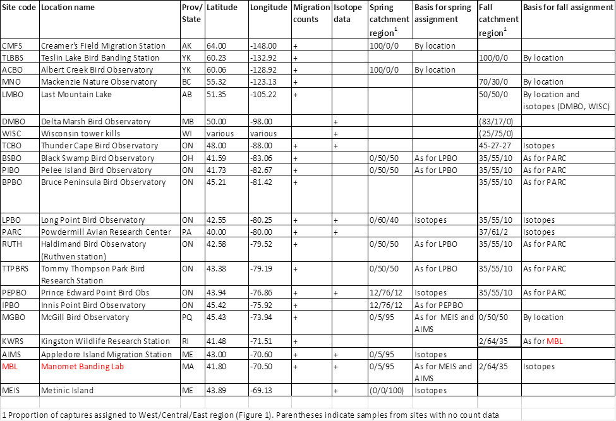
Appendix A: Details of stable isotope breeding origin estimation for Blackpoll warblers (Setophaga striata)

Appendix B: Prior specification
Parameter | Prior | Notes
$$α_{j}$$ | Fixed to 0
$$β_{j}$$ | Normal(0,1)
$$ϵ_{j}^{2}$$ | Uniform(0,5)
$$ρ_{j,s}$$ | Lognormal(0,100)
$$µ_{s}$$ | Uniform(0,60) | “Day of the year” was standardized for each season, such that day 1 represented the earliest date any station began counting birds during that migration season. This prior represents equal probability that the “peak date” of migration during the season occurred on any day during a 2-month seasonal monitoring window.
$$σ_{s}$$ | Uniform(0,60)
$$ω_{s}^{2}$$ | Uniform(0,5)

Appendix C: Simulations
Simulations confirmed the ability of this model to accurately estimate regional population trends (Figure C1). Our simulations included realistic variance in annual and daily migration counts and included realistic sample sizes for stable isotope assignments (i.e., the same sample sizes and number of stations as in our empirical data). Simulations also included the same amount of missing data (for both migration counts and breeding origin assignments) as in the empirical data.
We simultaneously used these simulations to evaluate whether the migration monitoring network as a whole is able to accurately estimate trends, given the estimated catchment each station receives. To do this, we extracted empirical estimates of regional migration probabilities at each station (during fall migration) and used these migration probabilities to simulate migration counts at each station, conditional on simulated regional population dynamics. For example, the model fit to empirical data indicated that LPBO received primarily western birds, while MCCS received a mixture of birds from all strata (Appendix B). Thus, simulated data at LPBO more strongly reflected western population dynamics than MCCS.
Critically, when we fit the Bayesian statistical model to the simulated data, we did not enter these migration probabilities as data. Instead, the model re-estimated them using only a small sample of simulated “known origin” birds at several stations, combined with simulated daily migration counts at each station.
We generated 50 independent simulated datasets (each 18 years in duration), wherein we generated random temporal slopes (ranging from -0.2 to 0.2) and log-normal annual process variance (with log-scale standard deviation ranging from 0.1 to 0.3) for each region. In each simulation, observed counts at each station were simulated, conditional on the simulated annual abundance in each region, migration probabilities from each region to each station, and process/observation variance components at each station.
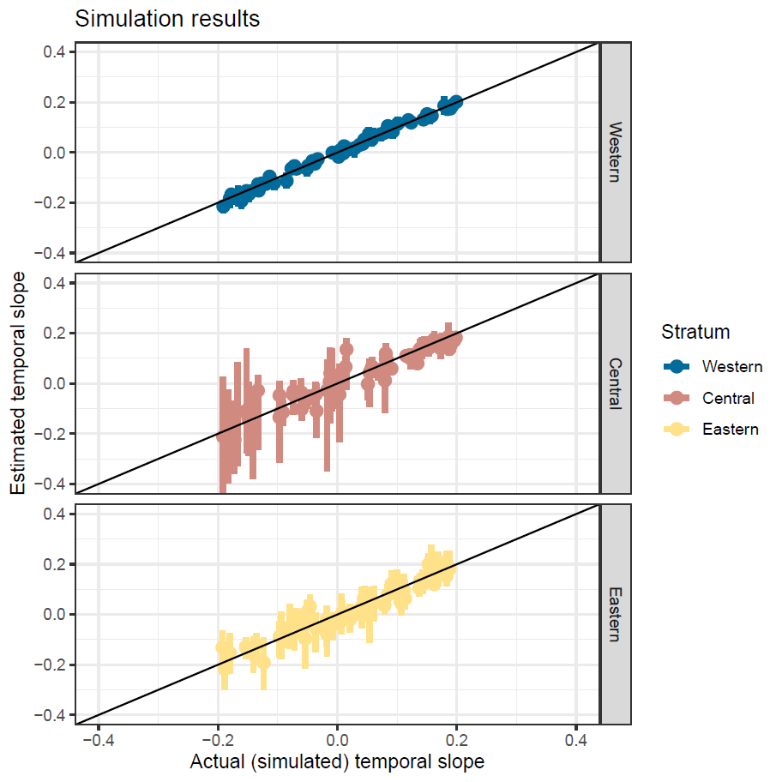
Figure C1. Comparison of actual (i.e., specified in simulations) and estimated trends in each of three strata for 50 repeated Monte Carlo simulations, in each of which random stratum trends between -0.2 and 0.2 were simulated.
Appendix D: Expanded results
Population trend and change analysis from 2008 to 2018 (10-year trend) for Blackpoll warblers (Setophaga striata)
Stratum | Season | % Change | Trend | P(Increase) | P(30% decline)
Eastern | Fall | -78.9 (-92.8 to -37.9) | -0.14 (-0.2 to -0.05) | 0 | 0.98
Central | Fall | 129.7 (-20.9 to 724.7) | 0.09 (0 to 0.23) | 0.93 | 0.01
Western | Fall | 72.5 (0.3 to 182.9) | 0.06 (0 to 0.11) | 0.98 | 0
National | Fall | 23.7 (-26.4 to 138.7) | 0.02 (0 to 0.09) | 0.79 | 0.02
Eastern | Spring | -44.1 (-73.4 to 8.2) | -0.06 (-0.1 to 0.01) | 0.04 | 0.75
Central | Spring | 29.8 (-38 to 170.5) | 0.03 (0 to 0.1) | 0.77 | 0.05
Western | Spring | -16.6 (-100 to 154.6) | -0.02 (-0.6 to 0.1) | 0.36 | 0.38
National | Spring | -25.7 (-93.4 to 26.8) | -0.03 (-0.2 to 0.02) | 0.12 | 0.41
National | Composite | -5.6 (-36.8 to 35.4) | -0.01 (0 to 0.03) | 0.37 | 0.06

Population trend and change analysis from 2000 to 2018 (18-year trend) for Blackpoll warblers (Setophaga striata)
Stratum | Season | % Change | Trend | P(Increase) | P(30% decline)
Eastern | Fall | -72.2 (-97.9 to 113.2) | -0.07 (-0.2 to 0.04) | 0.12 | 0.8
Central | Fall | 173.9 (-29 to 926.4) | 0.06 (0 to 0.14) | 0.92 | 0.02
Western | Fall | 200.3 (64.1 to 389.6) | 0.06 (0 to 0.09) | 1 | 0
National | Fall | 61.4 (-69.8 to 277.1) | 0.03 (-0.1 to 0.08) | 0.77 | 0.12
Eastern | Spring | -60.1 (-83.1 to -18.9) | -0.05 (-0.1 to -0.01) | 0.01 | 0.94
Central | Spring | 1810.7 (94.2 to 27786.4) | 0.18 (0 to 0.37) | 1 | 0
Western | Spring | -96.1 (-100 to 92.9) | -0.17 (-0.6 to 0.04) | 0.07 | 0.89
National | Spring | -89.2 (-100 to -9.6) | -0.12 (-0.4 to -0.01) | 0.02 | 0.93
National | Composite | -7.4 (-48.7 to 51.5) | 0 (0 to 0.02) | 0.38 | 0.16

Fall migration, expanded results for Blackpoll warblers (Setophaga striata)
Figure D1. Annual indices of fall abundance ($T_{s,y}$) at each migration monitoring station for Blackpoll warblers (Setophaga striata)
Figure D2. Annual estimates of fall composition ($T_{s,y} × \frac{M_{1,s,y}}{E_{s,y}}$) at each migration monitoring station (only mean estimate is shown, but note that there are uncertainty around these composition estimates).

Figure D3. Annual estimates of abundance in each stratum based on fall migration monitoring across the entire study (2000 – 2018).

Figure D4. Annual estimates of abundance nationally across the entire study (2000 – 2018) based on fall migration monitoring.
Spring migration, expanded results
Figure D5. Annual indices of spring abundance ($T_{s,y}$) at each migration monitoring station.
Figure D6. Annual estimates of spring composition ($T_{s,y} × \frac{M_{1,s,y}}{E_{s,y}}$) at each migration monitoring station (only mean estimate is shown, but note that there are uncertainty around these composition estimates).
Figure D7. Annual estimates of abundance in each stratum based on spring migration monitoring across the entire study (2000 – 2018).

Figure D8. Annual estimates of abundance nationally across the entire study (2000 – 2018) based on spring migration monitoring.
Composite analysis (2000-2018)
Figure D9. Estimates of national-level blackpoll warbler population trajectory (from 2000 to 2018) derived by summing fall trajectory for Western stratum and spring trajectory for Central and Eastern strata.
Appendix E: Sensitivity analysis by sequentially omitting each station’s data
[re-running analysis currently]

